The Desktop GIS OpenJUMP: A hands-on introduction


for OpenJUMP 1.4.2

Stefan Steiniger and Michaël Michaud

this is a (text-) updated version of the
OGRS 2009 Workshop tutorial for OpenJUMP 1.3

Version: 10. Oct. 2011

Table of contents

Introduction page 3

I - Using OpenJUMP page 5

1. Loading and displaying data page 5
2. Working with alphanumeric data page 9
3. Thematic maps page 14
4. Exporting views page 16
5. Printing page 17
6. Querying data page 20
7. Geometric data creation and editing page 24

II - Using OpenJUMP with PostGIS page 26

1. OpenJUMP and PostGIS page 26
1.1 Creating a database page 26
1.2 Loading the PostGIS extension page 27
1.3 Using PostGIS page 28
1.3.1 Populating the database page 28
1.3.2 Loading data from the database page 29
1.3.3 Performing SQL queries page 30

Acknowledgments - The tutorial is based on original workshop material by E. Bocher and A. Lepetit prepared for the FOSS4G 2006 conference in Lausanne.

Introduction

Summary

The aim of the workshop is to introduce the free GIS software OpenJUMP and to show how OpenJUMP can be used to visualise, create, edit and analyse geographic data. With those capabilities OpenJUMP is a full functional Desktop GIS that can be used in several places of a Spatial Data Infrastructure (SDI). Figure 1 illustrates the use of desktop GIS in a SDI context.

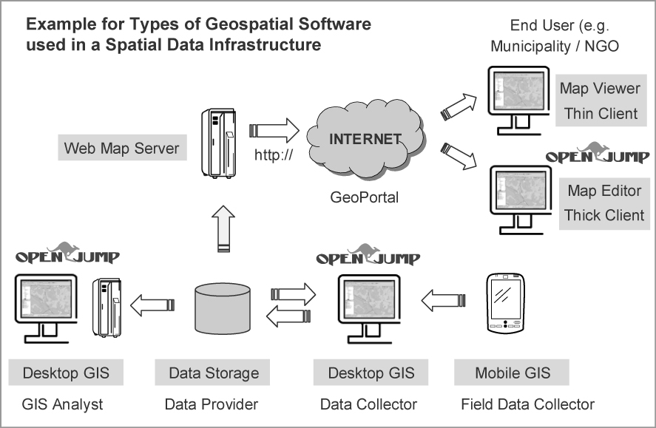Figure 1 - Using OpenJUMP in a Spatial Data Infrastructure (SDI)
This document is organised in two parts which allow to get to know OpnenJUMP step-by-step.

1. Using OpenJUMP
The first part guides you through some basic OpenJUMP skills. You will learn how to :
- load and display data,
- work with alphanumeric data,
- create thematic maps,
- export views
- print
- query and analyse data
- create and edit geometry data

2. Using OpenJUMP with PostGIS

This part will demonstrate how it's possible to write, access and query data stored in the PostGIS database. You will learn how to:
- store data to PostGIS
- read data from PostGIS
- query the data with spatial and numeric predicates,
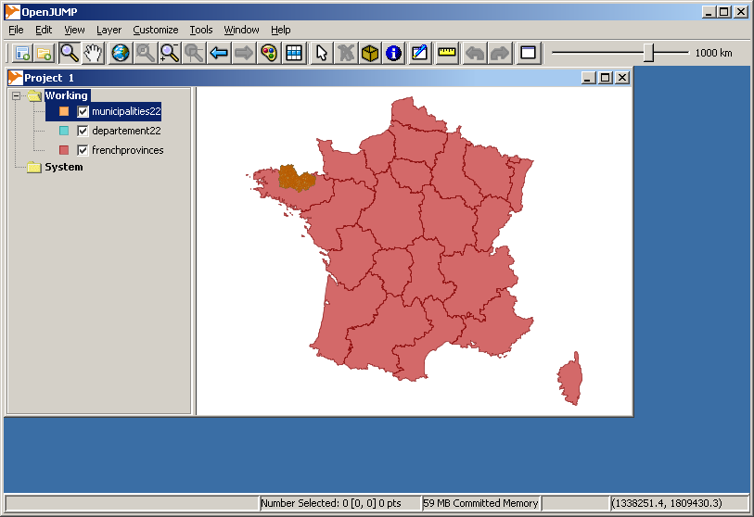Figure 3
- build expressions with more than one criteria

Requirements

You should know the basic GIS concepts, for instance you should know the difference between raster and vector data, you should know basic analysis functions such as buffering and overlay (intersection) operations, and you should know the principles of cartographic representation and classification.

Working fully through the tutorial will require about 2 hours. Trained users will need 70 mins for Part 1 and 10 min for Part 2 .

Materials

For going through the tutorial you need :
- OpenJUMP 1.4.2 - available on http://www.openjump.org, We recommend downloading the OpenJUMP PLUS edition.
- The following OpenJUMP plugins (extensions) installed – that are contained by default in the OpenJUMP PLUS edition:
- CadPlan's JumpPrinter extension (http://www.cadplan.com.au/)
- PostGIS plugin (http://sourceforge.net/project/showfiles.php?group_id=118054)
if you don't have them installed, you can download them and put the libraries in the OpenJUMP subfolder “/lib/ext/”
- the PostgreSQL 6.3 database (the PostGIS extension and pgAdmin should be included in the PostgreSQL distribution) available at http://www.postgresql.org/ and http://postgis.refractions.net
- LibreOffice 3.4 available from http://www.libreoffice.org/,

And the spatial data delivered with this tutorial (see the table below).

Data

Data | Geometry | Description
frenchprovinces | polygon | Regional country
departement22 | polygon | French sub country after province
municipalities22 | polygon | Municipalities for Côtes-d'Armor departement
watershed | polygon | Watershed name's Sterenn
subwaterhed | polygon | Sub watershed in Sterenn
wsmunicipalities | polygon | Municipalities crossing Sterenn watershed
waternetwork | line | Ditches and rivers in Sterenn watershed
landcover2000 | polygon | Land cover classification in 2000
hedgerow | line | Hedges network in Sterenn watershed
F018_024.TIF | Raster images | Topographic map (tif + world file)
F018_025.TIF | Raster images | Topographic map (tif + world file)
photo2.ecw | Raster images | Aerial photography (ecw)
photo3.ecw | Raster images | Aerial photography (ecw)
pop22-5499.ods | --- | Population by municipality 1954 to 1999 in Côtes-d'Armor (Bretagne), Department 22

I - Using OpenJUMP

- Loading and displaying data

  - Loading and organising data

When OpenJUMP starts, you see a main window named “project” (Figure 2). A “project” is not only a window which allows data visualisation and organisation but it’s a file too, which contains all the work you perform with OpenJUMP (.jmp extension).
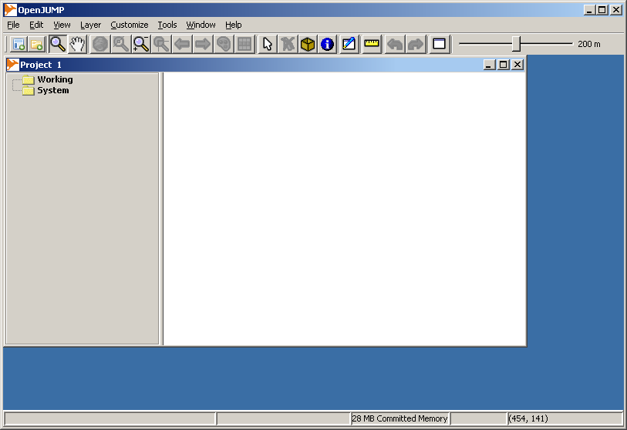Figure 2 - OpenJUMP 1.4.2 workbench
First, you will load some vector data layers. To do so choose from the Menu [File>Open...] and click on “File” icon in the left sidebar - and select:
- frenchprovinces.shp,
- departement22.shp,
- municipalities22.shp,
Another option to load vector data on Windows systems is to “drag & drop” files.

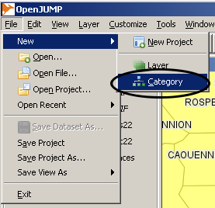Figure 9 - creating a new category

The layers that have been loaded are listed in a table of contents, to the left of the visualisation window (figure 3). We will call this window Layer View.

There are several ways to move in the Layer View and to zoom in or out of the area shown. Try out the navigation tools that are provided (i) in the toolbar and (ii) in the [View] menu; or by choosing a function from the mouse context menus accessible via a right-mouse-click on (iii) category name (e.g. “Working”) or (vi) layer name (e.g. municipalities22).
zoom in/out, | or use the mouse wheel
pan map view
zoom to full extent | or [View>Zoom To full Extend]
zoom to previous/next view
zoom to fence
zoom to selected items | or [View>Zoom To Selected Items]
zoom to scale | [View>Zoom to Scale]
zoom to layer or layers | see the layer context menu

  - Modifying layer properties

To modify the display of a layer you can use the Styles dialog (figure 4).
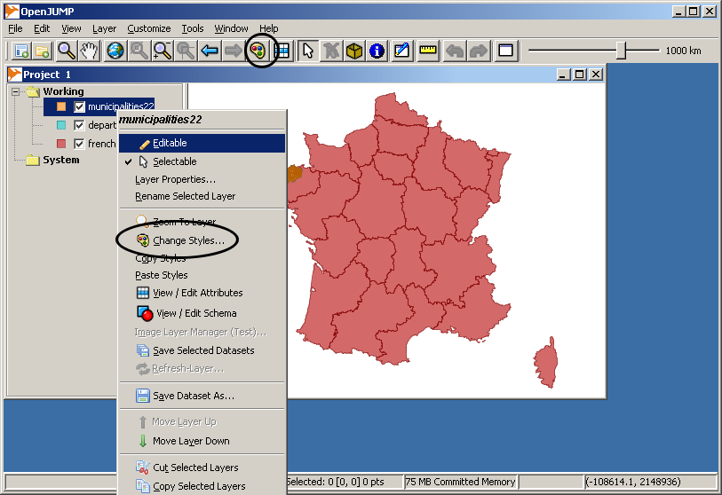Figure 4 - accessing the style dialog via the toolbar or the context menu. (Note: in OpenJUMP 1.4.2 we moved the “Change Styles...” context menu into a new “Style” menu item of the layer context)
- The Rendering Tab (figure 5) enables you to change general properties (colour, transparency, line width and pattern, vertices visibility).

- The Scale Tab (figure 6) allows you to customise the display of a layer with respect to the zoom scale. So you can define that a layer can be shown only between a smallest and a largest scale. To obtain the current scale you can use [View>Scale Display].

- The Labels Tab (figure 7) enables you to define labelling options (font type, colour and height and placement options). For that it is important is to know the attribute that contains the text to display.
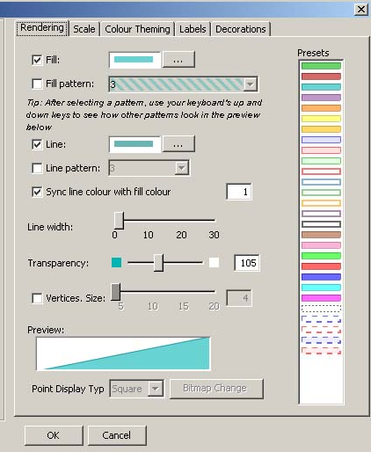Figure 5 - Rendering dialog | 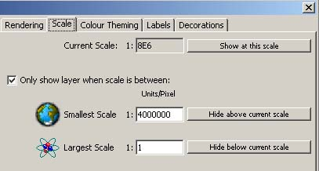Figure 6 - map visibility dialog
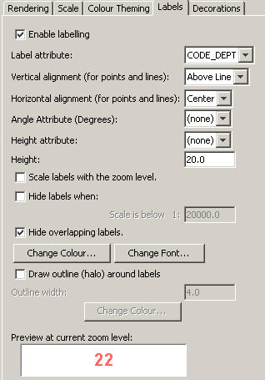Figure 7 - Labelling dialog | 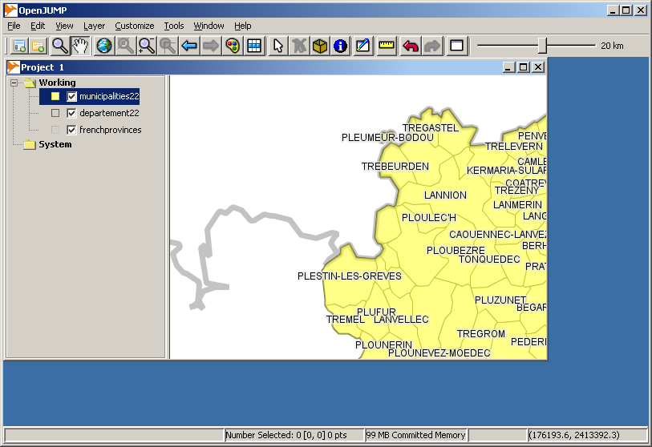Figure 8 - customized display of our dataset
  Exercise 1 (figure 8)
  Symbolise frenchprovinces
  - uncheck fill
  - change line colour to grey with width=7
  Symbolise departement22
  - uncheck fill
  - make lines black with width=2
  Symbolise municipalities22
  - Use from the preset styles the yellow one
  - Label using attribute “name_mun” check the box “Draw outline (halo) around labels”
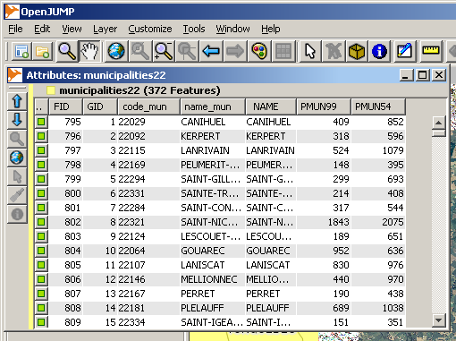Figure 17 - Added table data from the CSV file.

In the next step you should load some raster files into OpenJUMP using [File>Open File...] after creating a new category Fond in the Layer View. This allows for easier management later on. You can create (using [File>New>Category]), rename and move the categories in the layer view and order them as you want (figures 9, 10 and 11). Now load the following image datasets:
- photo2.ecw (note: *.ecw files can only loaded with MS Windows)
- photo3.ecw
- F018_024.TIF
- F018_025.TIF
If the *.TIF images are not displayed, try to load them with [File>Open...] and choosing the option “Sextante Raster Image” on the left. To load images with this option is necessary if they should be analysed with the Sextante Toolbox.
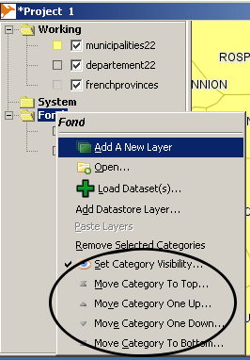Figure 10 - category context menu
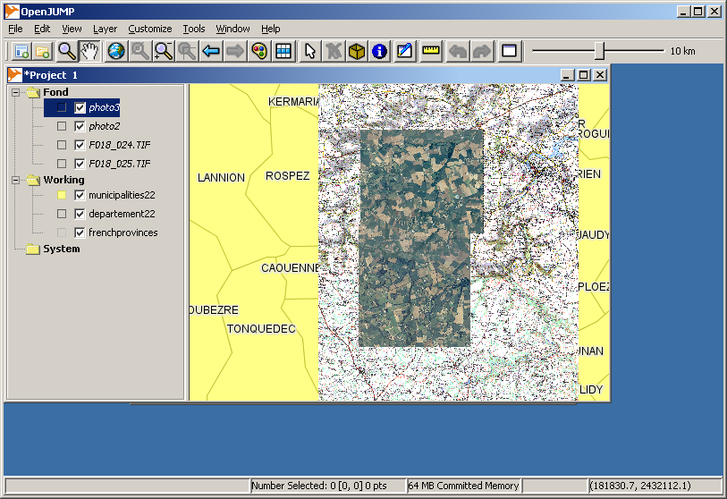Figure 11 - displaying vector and raster image layers combined

Exercise 2: customise the display of the raster image for certain zoom levels

use the Style dialogs accessible via the layer context mouse menu and try to:
- set for F018_024.TIF and F018_025.TIF the smallest scale = 15'000
- If you have OpenJUMP running on Windows load photo2.ecw and photo3.ecw - set the smallest display scale to 12'000 (otherwise skip this step)

The see the current display scale in the map view use [View>Scale Display]

- Working with alphanumeric data

  - Viewing attributes

In a layer, each feature has alphanumeric attributes. If you want to inspect the attributes of a layer, then you can use the table icon from the toolbar or choose [View/Edit Attributes] from the layer context menu (see figure 12).
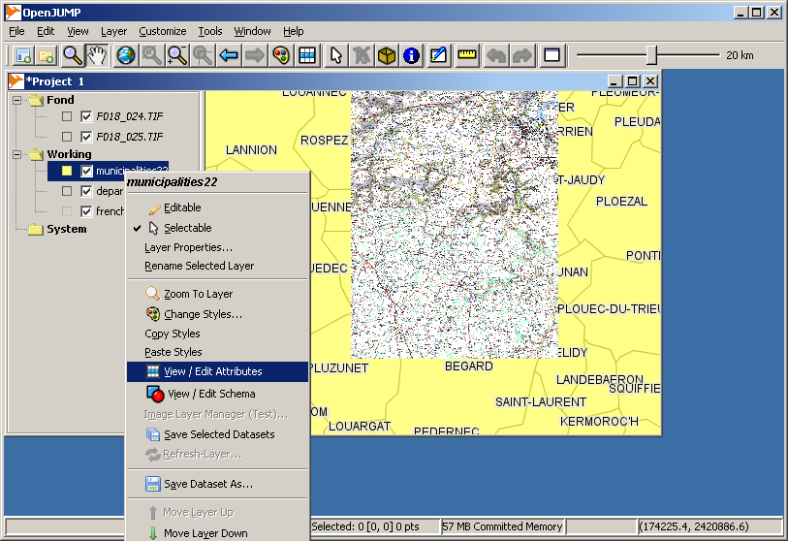Figure 12 - accessing the attribute view / table view

For the municipalities22 layer you will see a new window named “Attributes” as in figure 13.

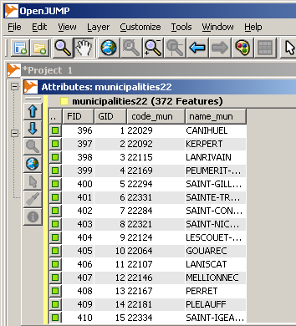Figure 13 - the attribute window

Another way to view attributes for a particular object is to use the Feature Info Tool from the toolbar:

  - Importing and joining alphanumeric data

In the next step we want to join demographic data stored in a table (from Excel or LibreOffice) with the polygons that describe the municipal areas from our dataset “municipalities22”.

Open the file pop22-5499.ods with LibreOffice. Go to [File>Save As...]. Choose the format Text CSV (.csv) from the drop down list, click “save”, click in the next dialog on “Keep Current Format”, and set the values in the following dialog as given in figure 14 (Text delimiter field is empty). Save with click on “ok”.
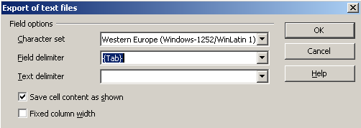Figure 14 - exporting table data to CSV format in LibreOffice.

Now we go back to OpenJUMP and chose from the menu [Tools>Edit Attributes>Join TXT table...] (figure 15).

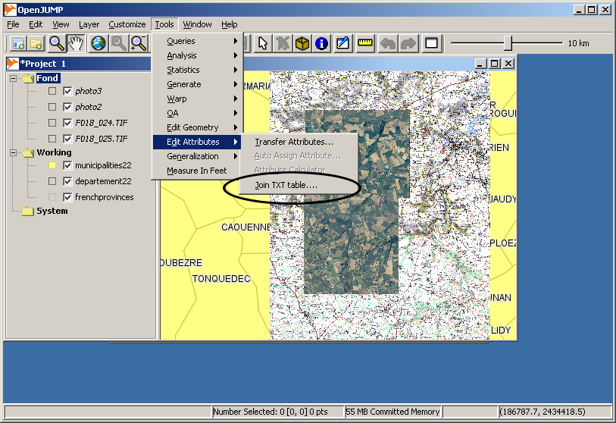Figure 15 - Selection of the join TXT table function.

In the dialog that appears navigate to the folder where you stored the file pop22-5499.csv, chose from the file types drop down menu “All Files” and select the CSV file. In the next dialog chose the dataset/layer to which we like to append the fields, i.e. municipalities22.
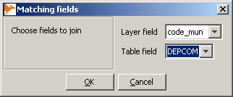Figure 16 - Setting the unique keys.

In the following dialog we will need to select a unique key in both datasets that allows us to attach the information contained in the table data with the information in the geographic dataset. Set the values as shown in figure 16.

Afterwards the attributes of the csv file are attached to the layer's attribute table (figure 17).

To keep the result, you need to save the layer by choosing from the municipalities22 layer context menu (right mouse click on layer name) the function [Save Dataset As...]. Choose the appropriate file type for saving – e.g. *.shp or JUMPs GML format (*.jml).

  - Editing attributes of a layer

With OpenJUMP you can easily add or remove fields from a table when the layer is editable. Right-click on the layer municipalities22 and check “Editable” (figure 18). If the layer is editable the layer name should be displayed yellow in the Layer View. You will also notice that a toolbox will appear that allows to edit geometries in that layer.
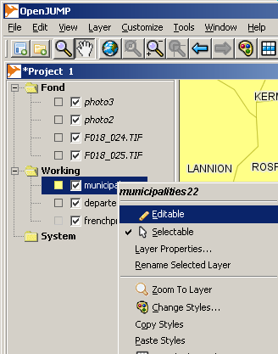Figure 18 - Making a layer editable.

Now we select from municipalities22 context menu [View/Edit Schema]. A new window appears that lists all attributes with their names and the data type (e.g.: String, numeric types, or Geometry).
Click on the lasted row to add a new field “area”. Click on the corresponding data type field and chose from the dropdown list the data type “Double”. Click “Apply Changes” (figure 19).
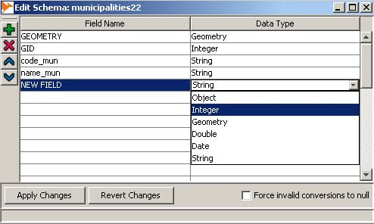Figure 19 - Adding a new attribute to a dataset.

After this is done we can populate the attribute “area” with values for each geometry.
In our case we want to calculate the area of each municipality and write that value into the field. To do that chose from the menu [Tools>Edit Attributes>Calculate Areas and Lengths...]. Select what kind of operation you want to do and specify the correct attribute (figure 20).
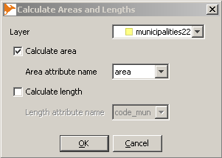Figure 20

The results are expressed in m². For our purposes this unit it is not very comfortable so we will convert it into km². The Attribute Calculator lets you perform simple calculations on all records for one attribute.
- Open the calculator: [Tools>Edit Attributes>Attribute Calculator].
- Set in “name of new attribute” field: “AREA_KM2”
- Chose type: DOUBLE
- Set the expression as in figure 21 (use the buttons “area” and ''/” and “copy value to formula” to avoid errors)
- Click “OK”
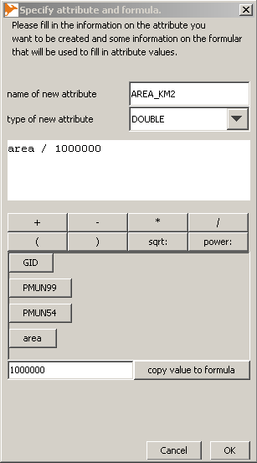Figure 21 - the attribute calculator

This tool will create automatically the new field (AREA_KM2) in the attribute table (figure 22).
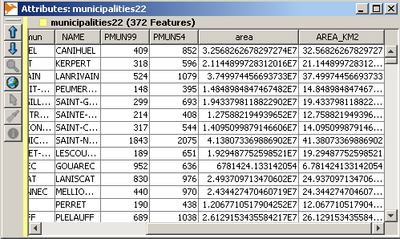Figure 22 - The new field AREA_KM2 created with the calculator.

Exercise 3 (figure 23)

Calculate population densities for the years 1999 and 1954 for the layer municipalities22 using the Attribute Calculator, and save the results.

The fields with the population counts are PMUN99 and PMUM54, respectively.

The population density is given as density_year = (population_count_year / km²).

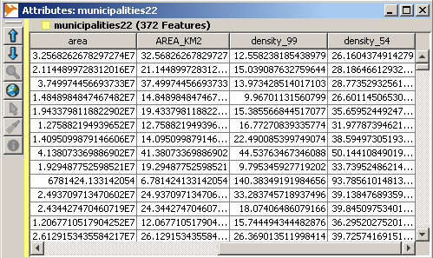Figure 23 - Result of Exercise 3, the calculated population densities.

- Thematic maps

Next we want to create some thematic maps to display and compare the population density overtime that we just calculated in the previous section (2.3). Hence we will utilize OpenJUMP functions to do a classification of the density data, and then use the viewing tools to visually compare between the population densities for the years 1954 and 1999.
- First, we create a new project [File>New>New Project].
- Select the layer municipalities22 in the original project and chose [Copy Selected Layers] from the layer context menu.
- Then go to the newly create project an chose [Paste Layers] from the category context menu for the category named “working”.
- Select [Window>Mosaic].
- Select [Window>Synchronization>Synchronize pan and zoom] Now click in one Map View and use the zoom and pan functions. The views should be synchronised (figure 24).
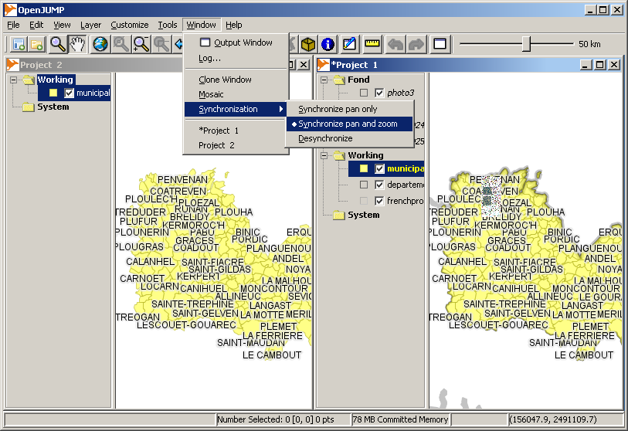Figure 24 - Synchronising Map Views of different projects.
Now we use OpenJUMPs colour theming functions from the Styling Dialog to display the population density in different colour scales (see figure 25 and 26). Open the “change styles” window (use the palette button). The Colour theming tab enables you to choose among several classification methods, the number of classes and the attribute that should be displayed in a colour. Apply the following colour theming: Quantile classification, 7 classes, green colour schema:
- project 1 : population density for 1954
- project 2 : population density for 1999
Note: Please control that after changing the classification method the correct attribute field is chosen. Values may be reset/changed after the classification method is changed.
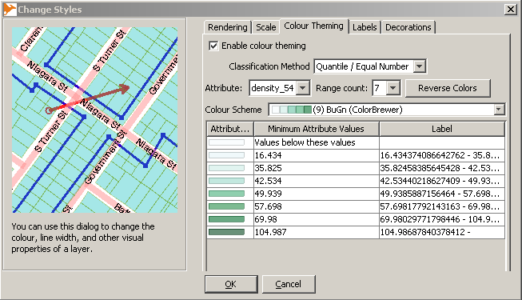Figure 25 apply colour theming to the dataset (result in Figure 26) (Note, the dialog layout changed slightly in Version 1.4.2)

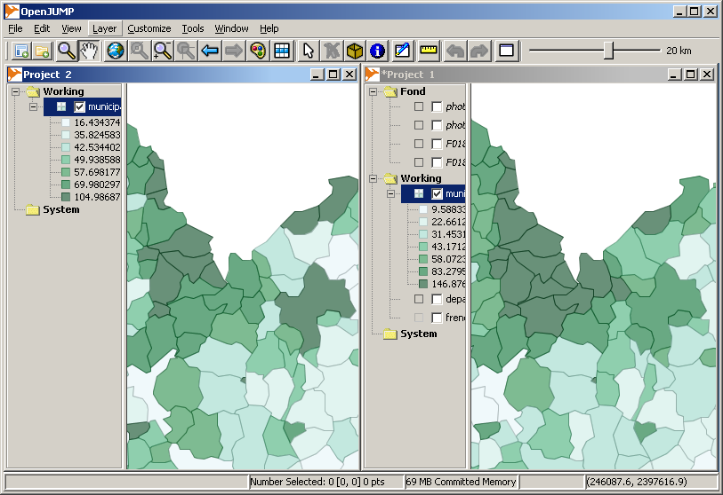Figure 26 - Result of the colour theming based on the population density. The ranges of the classes are different since the ranges are based on different data (i.e. densities for different years). So the views are not really comparable.
Besides the comparison for different years you may also compare the different visualisations for the different classification methods, e.g. Quantiles vs. Jenks Optimal Method. If you are finished zou should desynchronize the views and close Project 2, so that the original project is left.

- Exporting views

Currently OpenJUMP provides two build-in options for the export of Map Views. One can store an image in *.png or *.jpg format or one can export the map view as Scalable Vector Graphics (*.svg). With svg you can later do cartographic editing in a drawing and layout software such as Inkscape or Adobe Illustrator.
Before we export the image it is useful to add a scale bar to the view via [View>Scale Bar]. It is not advisable to add the map scale as a number (using [View>Scale Display]), since during printing and image export the final map scale (on paper) will likely be different. But the scale bar can be helpful to determine in what map scale the prints will be. Hence, you can test the existence of a difference between (i) map scale determined by OpenJUMP for the screen display, and (ii) the real map scale in the print, by measuring the length of a unit of the scale bar with a ruler on the print out.
To export the view chose [File>Save View As>....] (figure 27). If the map view is stored as raster graphics, then a geographic reference file (*.jgw or *.pgw) is written as well, if the option “Write world file” is checked (figure 28). The field labelled with “X” can be used to define the number of pixel for the width of the output image.
Thematic legends can only be saved as *.png images. To do so, click on the layer with the legend you want to save and chose from the layer context menu [Style>Save Legend...].

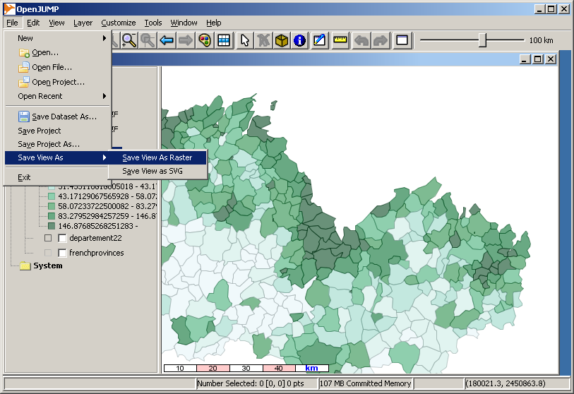Figure 27 - Saving a Map View as raster or vector graphics. (Note, the File menu in Version 1.4.2 shows more items)
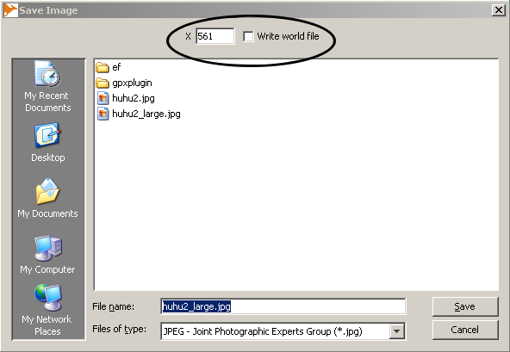

Figure 28 - Saving a Map View as raster image with options to write a world file and to define the image size. (In newer versions of OpenJUMP the checkbox is on the side of the file view)
- Printing

OpenJUMP does not have build-in printing functionality. However, two plug-ins/extensions exist that allow to generate maps: i) CadPlan's JumpPrinter Extension (available on www.cadplan.com.au), and ii) Intevation's PrintLayout Plugin (available from http://sourceforge.net/projects/jump-pilot/). However, in OpenJUMPs Plus edition the CadPlan plugin is included. Hence, for the following task we used the CadPlan extension.
First we do some preparation to print more than the areas of the municipalities:
- except for the municipalities22 layer make all other layers invisible by selecting them in the Layer View and chose then in the layer context menu [Toggle Visibility]
- open the Attribute Window of municipalities22 and go to the field that contains the population density for the year
- sort the field with the highest to lowest population density by clicking on the column header that contains the name (figure 29)
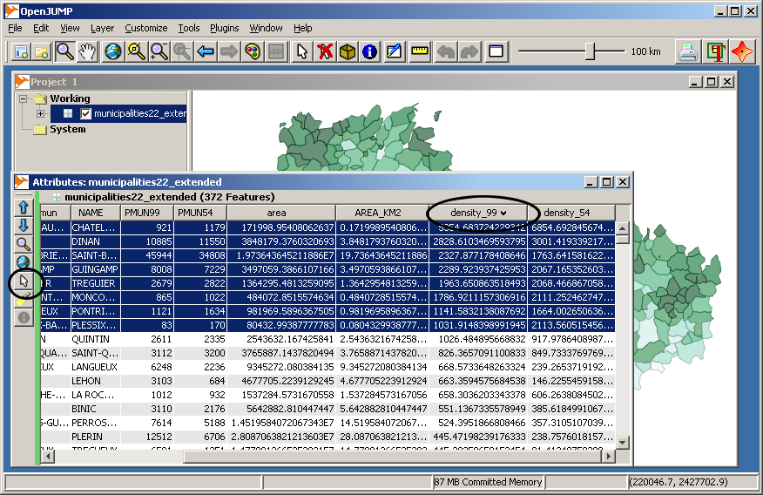Figure 29 - Sorting rows for population density.
- now select the top ten entries (highest density for 1999) and click on the select button on the left (figure 29) to select the municipalities in the Map View. Close the attribute window.
We copy those areas with the highest population density into a new layer to print only the name of those:
- while the 10 municipalities are still selected chose [Edit>Replicate Selected Item] and press the [ok] button in the upcoming dialog. A new Layer, called “new” will be created with those 10 areas. You can now deselect the areas using the “Clear Selection” button of the toolbar.
- now open the styles dialog for the layer “new” and in the Rendering Tab uncheck the box for Fill and set the line width to 3.
- Go to the Labels tab and enable labelling, choose “name_mun” as attribute to label, and check the box for “draw outline around labels” (figure 30)
- rename the layer “new” to “Top Ten” by double clicking on the name

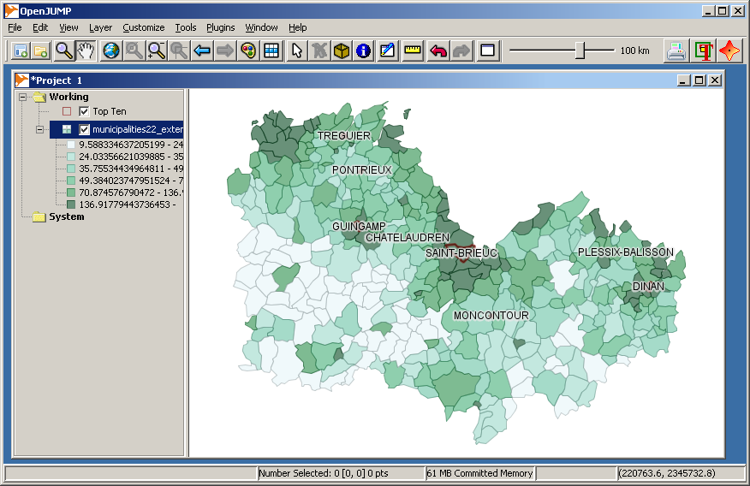Figure 30 - Municipalities with highest population density.
To print this map shown in figure 30 we click on the “Printer” button that is in the toolbar if CadPlan's JumpPrinter Extension is installed. A new window will appear (figure 31).
- click on the button [Page Setup] to a set the page to landscape format and use the button [-] on top to zoom out for checking the printer borders.
- set in the scale box the scale to the value 750000 – or check the box for “Fit to Page”
- click on the button [furniture] to add some map items of your choice, such as a scale bar, a north arrow, a legend, and so on (figure 32).
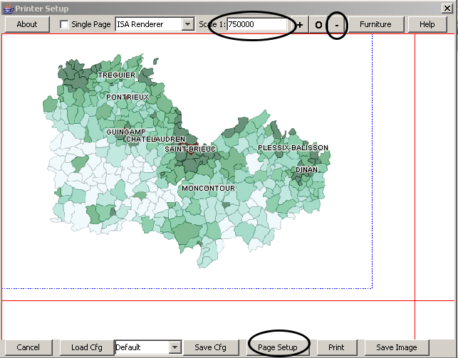Figure 31 - The print window of CadPlan's JumpPrinter extension. (In newer versions the dialog looks different)

Besides printing the result the CadPlan JumpPrinter Extension allows also to save the map as image in *.jpg, *.svg or *.pdf format if you use the [Save Image] button.
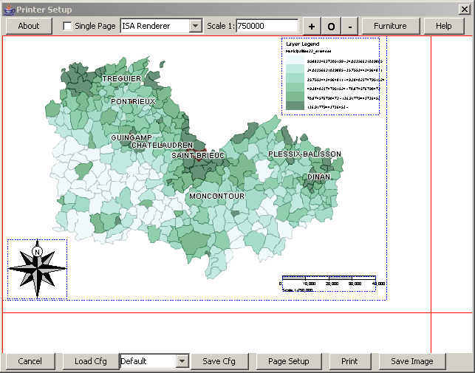Figure 32 - Map/Furniture Items added to the map.

- Querying data

In this section we will introduce you to the different data query tools in OpenJUMP. In general we will distinguish between Spatial Query tools and Attribute Query tools below. All query tools can be found in [Tools>Queries>...].

6.1 Simple attribute queries

Load the following datasets (figure 33) :
- landcover2000.shp,
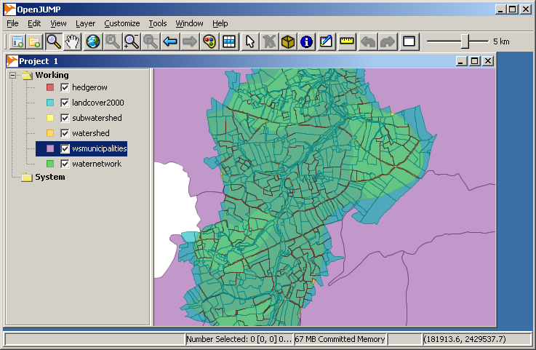Figure 33 - Data for the query exercise.
- waternetwork.shp
- hedgerow.shp,

Example 1: We want to select forest parcels (from landcover2000) with areas exceeding one hectare (i.e. 10'000 m²) and set the parcels type attribute value to “big forest”. This query needs to be subdivided into two queries. With the first we will obtain all forest parcels and with the second we retrieve all parcels that exceed 1ha.
- Go to [Tools>Queries>Simple Query...]. This function will open a new dialog named “Query Builder” (figure 34). The Query Builder enables to save your queries and to choose what kind of result you want (features selection, table display, or new layer)
- Select the forest parcels according to the settings in figure 34. Click on the [valid] button to accomplish the selection.
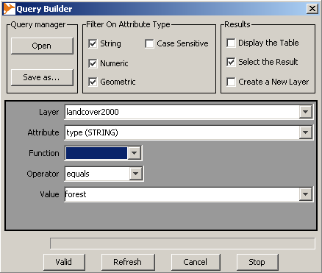Figure 34 - The query builder of Simple Query.

- Change the value in the field “Layer” from “lancover2000” to “Selection” using the dropdown list. Then set the other values in such way that we retain areas larger than 1ha (figure 35). 26 forest areas should be selected now (Figure 36).
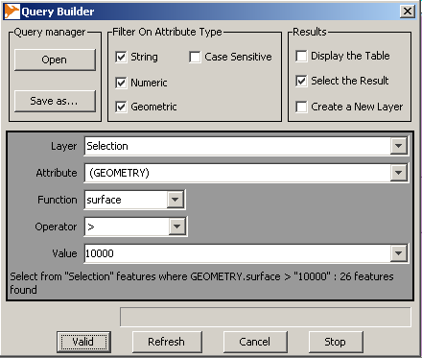Figure 35 - Selecting only larger parcels.

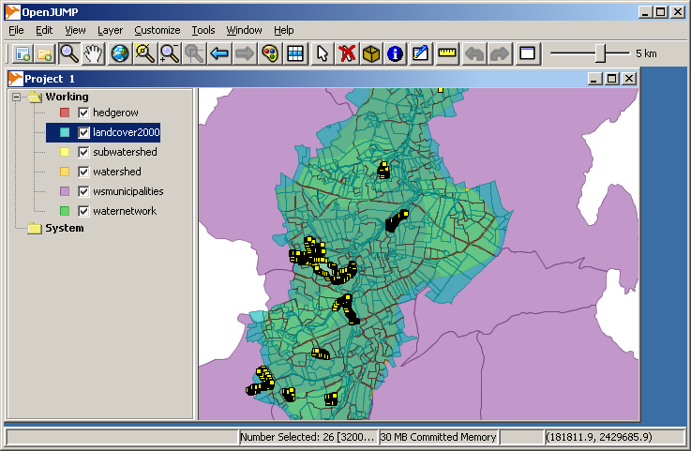Figure 36 - Selected larger forest parcels from landcover2000.
To change type value for the selection parcels we do the following:
- make the landcover2000 layer editable
- go to [Tools>Edit Attributes>Auto Assign Attribute...], which opens a new dialog (figure 33)
- set the correct layer (landcover2000) and destination attribute (type), uncheck the box for Auto-increment, but leave the box for “Selected features only” checked. Set as value: “big forest” (figure 37) and click “ok”.
- check with the Feature Info Tool from the toolbar (blue i-icon) or within the attribute window if the values changed
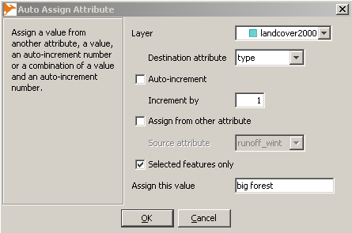Figure 37 - the “Auto Assign Attribute” dialog

6.2 Spatial queries

Spatial queries have a spatial component and are used if we ask questions such as: What objects are within a certain distance of object A? Or: What objects are within object A? Hence, spatial predicates such as “contains”, “within”, “touches”, “overlaps”, etc. are used in the query.
As an example for a spatial query we need to know what landcover2000 parcels are within 100 meters of the river network. For instance in the case that the river was contaminated by some chemicals. To answer the question we will not use “Simple Query” as above, which could be used as well to perform the task, but we will use “Spatial Query”. However, first we need to extract the rivers.
- Open [Tools>Queries>Attribute Query...] (figure 38, left)
- set the dialog fields as follows: i) source layer: waternetwork, ii) attribute: type_axe, iii) relation: “=”, iv) and in the Value field type “river”, v) keep “create a new layer for results” checked – and press “ok”.
Now a new layer called “waternetwork-=” is created that contains rivers only. Rename this layer to “river”. Next we perform the spatial query
- Open [Tools>Queries>Spatial Query...] (figure 38, right)
- set the dialog fields as follows: i) Source layer: landcover2000, ii) relation: is within distance, iii) Mask layer: river, iv) parameter: 100.0, v) keep “create a new layer for results” checked – and press “OK”.
The result of this query is returned in the new layer named “landcover2000-is within distance' (figure 39), which contains 646 parcels. This value can be derived from the dialog that opens if [Layer Properties...] from the layer mouse menu is chosen.
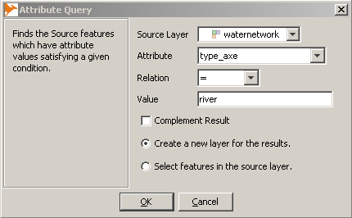 | 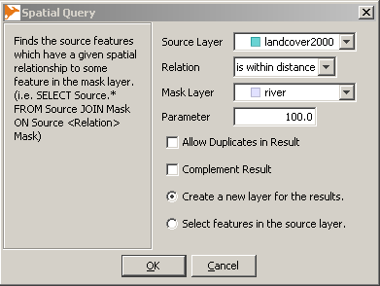
Figure 38 - left: Attribute Query dialog, right: Spatial Query dialog
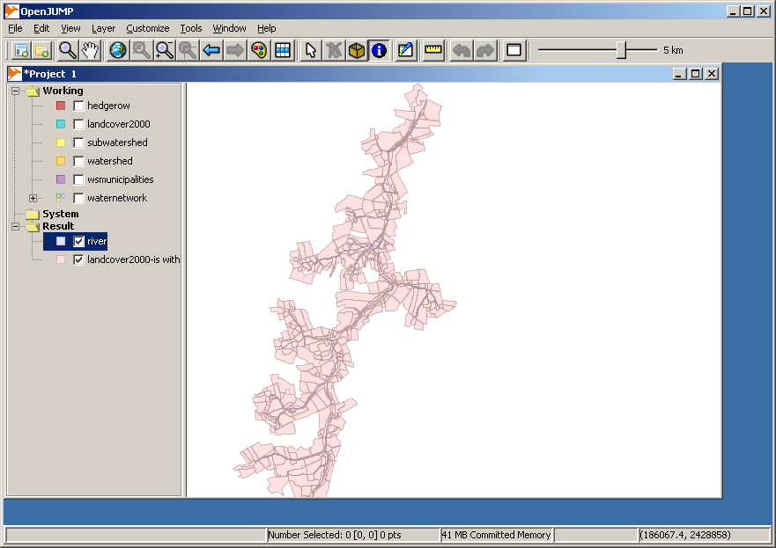Figure 39 - Land parcels within 100m distance to rivers.

Exercise 4

Exercise 4a

What landcover2000 parcels of the type “big forest” are within 100 meter of the rivers?
Note: You should find 20 parcels.

Exercise 4b

Which are the hedges (from layer hedgerows) that “touch” grassland parcels (from layer landcover2000)? Write down their total length and display the result in a new layer.
Note: To obtain the total length, i.e. the sum, you can use the function [Tools> Statistics>Layer Attribute Statistics...] that calculates statistics for any attribute value. As an alternative you can use the function [Tools>Statistics>Layer Statistics...] that calculates geometric statistics only.
The number of hedges should be 523, and the calculated total length should be 42'177.79m.

7. Creating and editing geometry data
Before starting with data creation and editing we need to load our basedata:
- Open the rasters files F018_024.TIF and F018_025.TIF.
- Modify the watershed styling so that the topographic maps can be seen.
- Extract into a new layer those features of the waternetwork dataset those attribute value of type_axe is equal to rivers. Name this layer rivers. (see the section on Attribute Queries)
- Symbolize the new layer rivers using a blue line with line width 4 (figure 40).
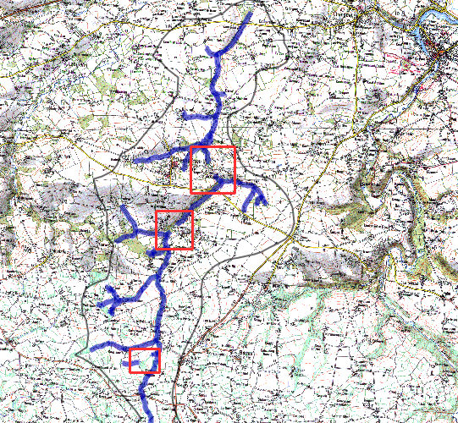Figure - The topographic maps and the rivers of the waternetwork dataset.

You will recognize the the rivers in the dataset are not continuous, i.e. that there are three breaks in the network (within the red boxes in Figure 40). The objective is to complete the river network by creating new features based on the topographic map.
- Make all layers except rivers un-selectable (layer mouse menu)
- Zoom near the red box in the north
- Make rivers editable
- Use the draw line tool to create a new line
If necessary reshape the line
- by adding,
- moving, or
- deleting vertices.

OpenJUMPs keyboard shortcut functions may be useful if one needs to zoom or pan while a drawing tool is activated. See in [Help>Shortcut Keys...] what functions are available.

If you have drawn the line we need to ensure that the (newly drawn) segments really touch each other (i.e. no under-shoots are created). Zoom in and use the Snap Vertices Tool by drawing a box around the end points of the segments.

 | Before snapping  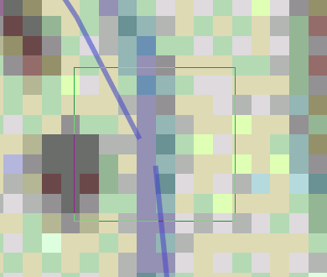 | After snapping  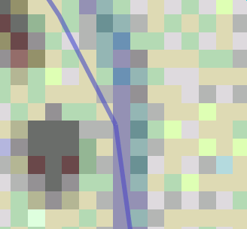

Next we need to set the attributes of the newly drawn segments.  Use the Feature Info Tool from the toolbar to display the attributes of each new segment.  Put the value “river” into the type_axe field for each new river segment (figure 41). | 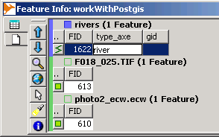Figure 41
If you are done with editing you should save the dataset. You can store the data in a file or in a database, such as PostGIS. To store the data in a file chose from the mouse layer context menu [Save Dataset As...].
How to store data in PostGIS will be described below in Part II.
With respect to this last exercise we note that storing in a database requires to have a unique key. If no “gid” (geomtry id) attribute exists in your dataset, which could hold as a unique access key, then you need to create one and assign unique values (see Part II - Section 1.3.1). Otherwise, if the “gid” attribute exists already, then you should assign unique values to the newly created river segments only. The sorting of the values in the table column may help you to find out what values have been used already.
II - Using OpenJUMP with PostGIS

- OpenJUMP and PostGIS

  - Creating a database in PostgreSQL/PostGIS

If you don't have access to a PostgreSQL database, then install it on your computer together with the pgAdmin software.  If you have so, start the pgAdmin tool that is used to manage the PostgreSQL database.  Go to [File> Add Server...]  Apply the following settings:  Name : localhost  Host: localhost (if PostgreSQL is installed on your computer)  Mainteance DB : postgres  Username : postgres  Password : leave empty (or: postgres)  DB restrictions: leave empty  Service : leave empty  You should obtain the database view in Figure 43. | 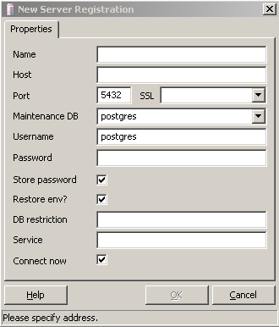Figure 42 - connecting to a database server

Next, we create a new database on the server using [New Database...] from the mouse menu (figure 44) with the following settings:
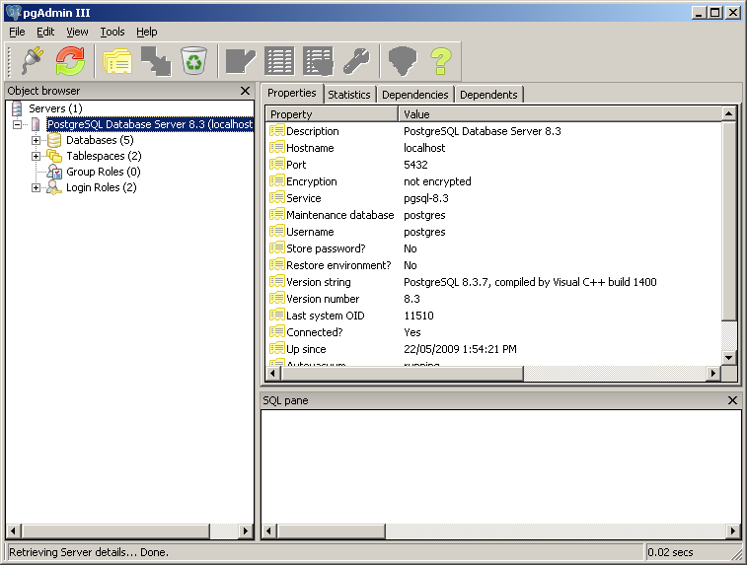Figure 43 - the pgAdmin interface
- Name: gisdb
- Owner: postgres (or the owner of your database installation)
- Encoding: UTF8
- Template: template_postgis (for the workshop use: gis_template)
If you can not select template_postgis then it may be necessary to carry out the steps in Section 1.2. If an error occurs ensure that the database with the template name shows a red cross, indicating that it is not accessed yet. If gisdb was created, continue with Section 1.3
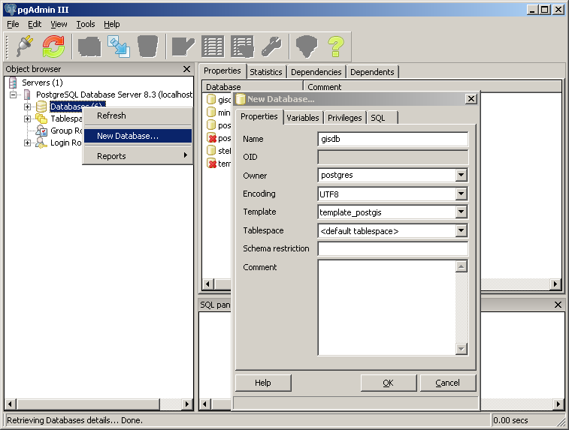Figure 44 - creating a new database
  - Loading the PostGIS extension
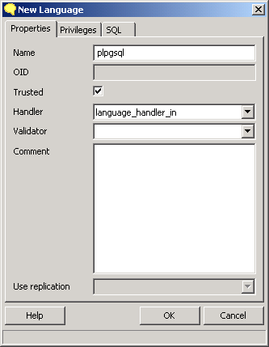Figure 45
If PostGIS is not installed for PostgreSQL yet, i.e. you could not chose the template “template_postgis”, then you may do the following:
The PostGIS extension requires the PL/PgSQL procedural language for some of its functions.
If PL/PgSQL doesn't exist. Right-click on language and set parameters like in figure 45.

Next we need to load the PostGIS functions.
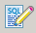
Open SQL query builder
1. Load the file lwpostgis.sql and execute it (figure 46)  2. Load spatial_ref_sys.sql | 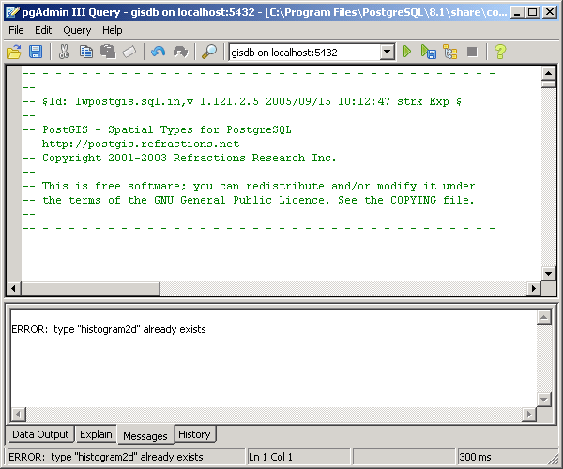Figure
Now we are ready to import and work with spatial data and features in PostgreSQL.

  - Using PostGIS in OpenJUMP

1.3.1 Populating the database

Preparing the data
Create a new project in OpenJUMP and load the following files:
"waternetwork.shp", "watershed.shp"
For each layer:
- In PostGIS tutorials the geometry attribute is often called: “the_geom”. In our query examples below we will use “geometry” instead of “the_geom”. However, if you wish to use “the_geom”, then do the following: Open the layer schema in OpenJUMP and change the name of the geometry attribute to “the_geom”. (figure 47)
- For storage of the data we need a unique access key for every object. Such key is in our case an attribute that contains a value only once. If such attribute is not already existing, we add an attribute “gid” of type integer to the dataset/ layer. Populate it with function [Tools>Edit Attributes>Auto Assign Attribute...] using the option “Auto-Increment”. Now, every object should have a unique key value.
- Change the SRID to the (French) projection of our dataset: EPSG:27582 - NTF(Paris)/Lambert II (étendu) by using [Layer>Change SRID...] (figure 48). Set value “27582”. If the SRID number is not known, it can be also set to “-1”.
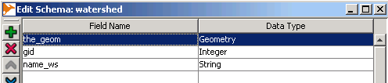Figure 47 - Using “the_geom” instead of “geometry”. | 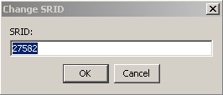Figure 48 - Set the SRID.
Storing the layers in the PostGIS database “gisdb”
Select the watershed layer to import  chose from the layer context menu [Save Dataset As...]  In the dropdown list for the storage format choose “PostGIS Table”. (Note that this option is only available when the OpenJUMP PostGIS plugin is installed)  Figure 49 shows parameters and the option to create a new table named watershed in gisdb database.  During the OGRS 2009 workshop use “postgres” as password.  Add also the waternetwork dataset to the database. | 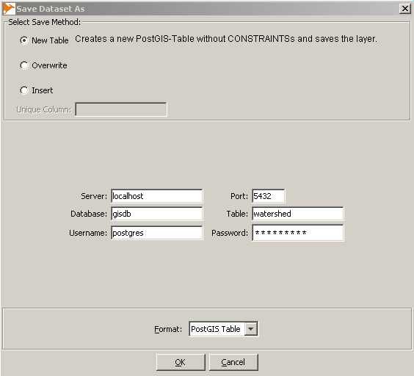Figure 49 - Committing data to the PostGIS database.
1.3.2 Display data from PostGIS in OpenJUMP
Open [File>Open...] and select “Data Store Layer” from the list of options on the left side. (figure 50)  In the new dialog click on the Connection Manger button on the left side (figure 50).  Again a new dialog will open to add a database connection (figure 52). Click on the [Add] button and fill in the fields as shown in figure 51.  Click [ok], and to return from the Connection Manager dialog (figure 52) click again on [ok], since we are already connected to the database. | 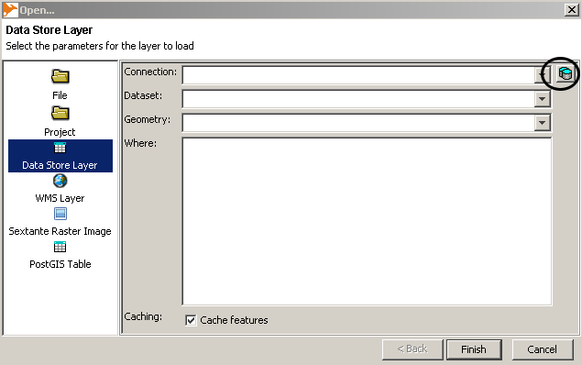Figure 50 - Loading data from a data store
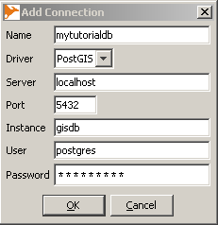Figure 51 - Adding a database connection. | 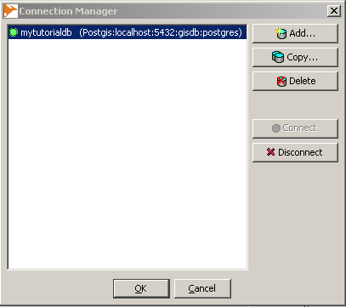Figure 52 - Connection Manager
If available, select from the drop down list the dataset you want to load (figure 53). Otherwise type the name in the “Dataset” field.  After clicking ok, the layer should be loaded in OpenJUMP.  Load from the database the layers waternetwork and water-shed. | 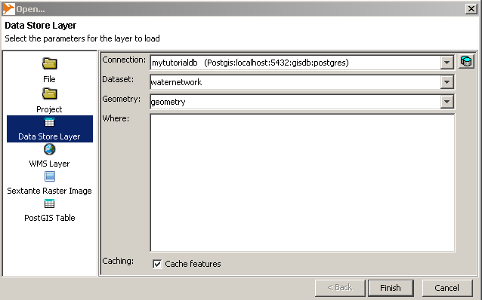Figure 53 - Open a dataset from a datastore
Note: If data are loaded with the “Data Store Layer” method then not all data are loaded in OpenJUMP, but only those data that are covered by the current map view (i.e. extent). Hence, if operations/calculations should be performed on the complete dataset, then one needs to zoom to the full dataset (layer mouse menu function: “Zoom to Layer”) and eventually duplicate all layer objects into a new layer first (by choosing from the mouse menu: 1. Zoom to Layer, 2. Select current layer items, and 3. [Layer>Replicate Selected Items]). That OpenJUMPs is displaying data in a dynamic fashion from data stores is sometimes recognizable by a small clock icon that shortly shows up next to the layer name. This icon indicates when data are requested from the database that are within the current map extents.
1.3.3 Performing SQL queries
To filter data in a PostGIS database and display the results in OpenJUMP you can use the Datastore Query function that provides a small GUI to run SQL syntax. Open the dialog by using [File>Run Datastore Query] or by selecting from the category context menu [Add Datastore Layer] (figure 54).
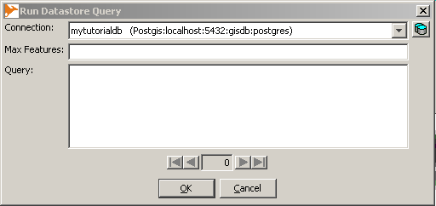Figure 54 - the Datastore Query Dialog to perform SQL queries in OpenJUMP.

If there are no databases provided in the “connection” drop down list, then you need to add a connection with the button shown on the right of the dialog. How to do that has been explained in the previous section.
Attribute queries can have this syntax:
SELECT ST_AsBinary(<geometry column>) AS the_geom, <column list> FROM <table> WHERE <column name>=<value>;

An example in which we want to obtain all objects in the waternetwork dataset those type is equal to ditch is given in figure 55.
The query text is:
select ST_AsBinary(geometry) as geometry, type_axe, gid from waternetwork where type_axe='ditch';
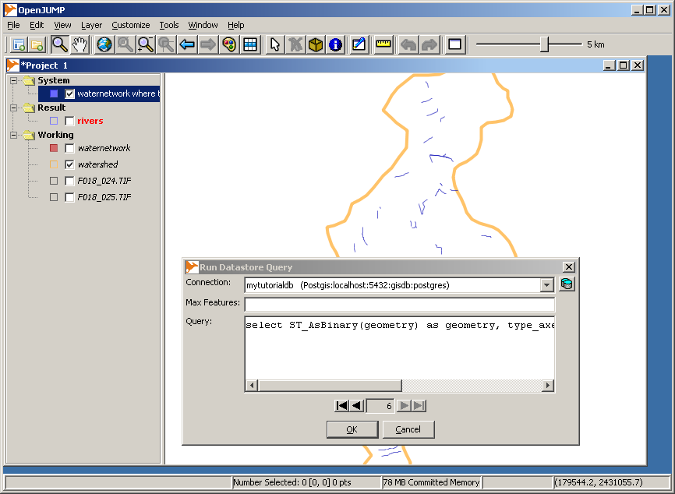Figure 55 - Selecting ditches from the waternetwork dataset.
In the second example we perform a spatial query that will return those river segments that have a certain length.
SELECT ST_AsBinary(geometry) AS geometry, type_axe, gid FROM waternetwork WHERE length(geometry) > 200;
Note that the length unit used here is metric (meters). The resulting layer should contain 35 waternetwork objects of length larger than 200m.
Exercise 5

After saving landcover2000 in PostGIS find those parcels that
- are grassland, and
- have an area greater than 2 hectares

The result must be display in OpenJUMP and layer must contains three columns: gid, type and area.

Notes:
- function area is area(<geometry column>)
- 10'000 square meters is equal to 1 hectare
Don't forget that SRID value is 27582 and the unit is metric.

It is also possible to perform queries that include several search statements. This is achieved by using the “and” statement.
In the example below we want to select parcels from landcover2000 dataset that are contained in areas of wsmunicipalities that have the municipality name “QUEMPERVEN”.
SELECT ST_AsBinary(landcover2000.geometry) as geometry, landcover2000.type FROM landcover2000, wsmunicipalities WHERE contains(wsmunicipalities.geometry, landcover2000.geometry) AND wsmunicipalities.name_mun='QUEMPERVEN';
The same query can be performed with pgAdmin. pgAdmin also allows to create very complex queries. However, when performing queries in pgAdmin we can not display the query output as a geographic data layer and we need to formulate the query like this:
SELECT landcover2000.type FROM landcover2000, wsmunicipalities WHERE contains(wsmunicipalities.geometry, landcover2000.geometry) AND wsmunicipalities.name_mun='QUEMPERVEN';

An extensive introduction and more examples on how to perform SQL queries with PostGIS are to be found in the PostGIS book: “PostGIS in Action” by R.O. Obe and L.S. Hsu (see http://www.manning.com/obe/). On our webpage openjump.org can be found also a second OpenJUMP - PostGIS tutorial on mineral targeting by Ravi Kumar, which presents further examples.

ECW files can only be load on Windows Systems since it is based on ERMapper *.dll libraries, and only if those files are placed into OpenJUMPs /lib/ext/ directory. Note that displaying *.ecw file on 64-bit systems may fail as well (see also: http://sourceforge.net/apps/mediawiki/jump-pilot/index.php?title=ECW).
On MacOSX the [Save Dataset As...] dialog did not work properly until OpenJUMP version 1.4.2. In that case you need to store to the existing municipalities22.shp file after making a copy first. However, better is to use the Nightly Build as of 7. Nov 2011 or the OpenJUMP 1.4.3 release.
Note, the JumpPrinter Extension requires the Vertex Symbols Extension.
Note, the FID attribute can not be used for this, since it is a dynamic attribute that is newly generated each time.
SRID: Spatial Reference ID
If you perform this SQL query with pgAdmin's query tool, then you may replace ST_AsBinary by asewkt, i.e. write: select asewkt(geometry)...

